Turbina Multirigo
T-BASIC
USE
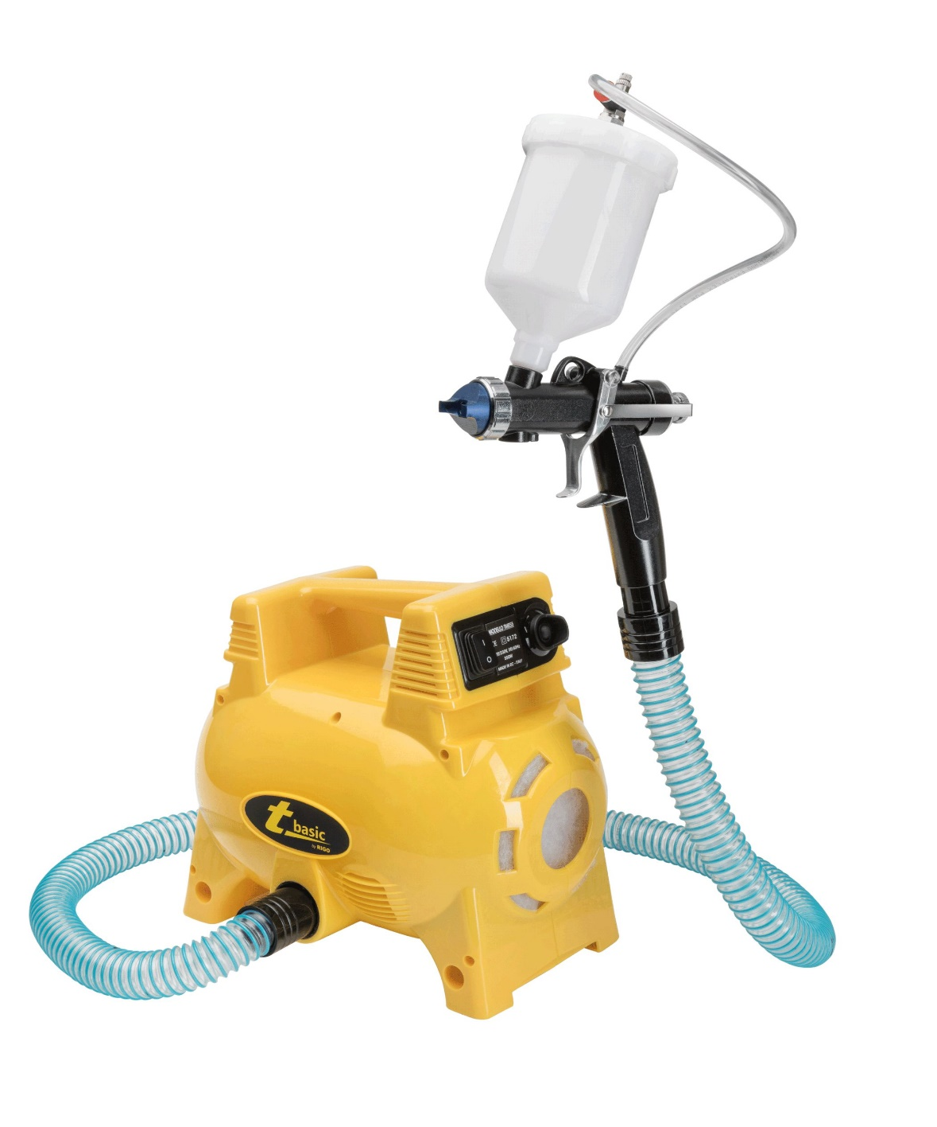
For further information about the sector of use please see the section fields of application

Workable covering materials

Water or solvent based varnishes* (enamels, rust preventers, fillers, flatting, etc.)
Wall paints (distempers, water paints, multicolour, fine quartz paints, etc.)

Please Note: to obtain products with good mechanical resistance and weatherability properties, observe the rules supplied by the manufacturer of covering products. Prepare the products following instructions of the latter

